CSCI 3901

**Software Development Concepts**



Faculty of Computer Science

**Lab 4: “VERSION CONTROL”**

Kishan Kahodariya B00864907

Dhruv Patel B00868931

**Part - 01**

**How many commits are there?**

* There are 9 commits.

**What is the commit message associated with the most recent commit?**

* Commit Message: “Whoops, forgot to ignore class files”

**Which Commit added the basePrices static variable?**

* Commit id: b590e9d
* Commit Message: “Factored prices into an array”
* **How many branches are there?**
* There are in total 4 branches:
  + Local (Master) branch
  + Three remote branch:
    1. Remote/origin/HEAD
    2. Remote/origin/coupon
    3. Remote/origin/master

**Which is the last commit on the coupons branch?**

* Commit id: 67ba33edfb465babbbae8d1cbe43cb4c78583cfe
* Commit Message: “Added coupon feature”

**Part - 02**

**Final output of git log**

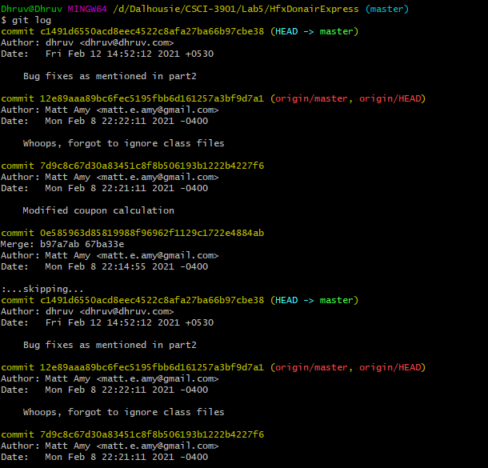

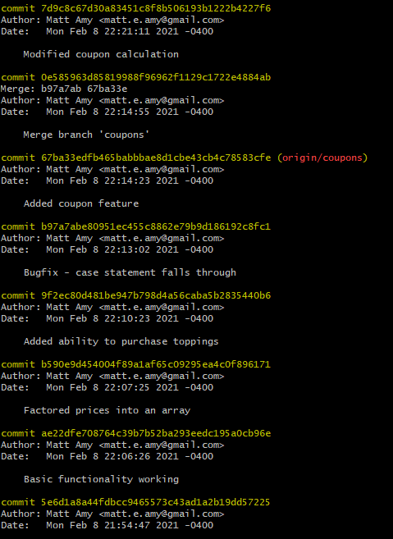

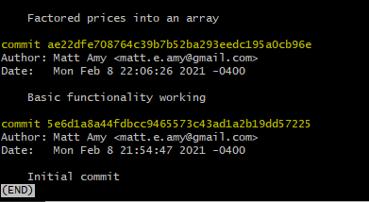

**Part - 03**

**Final output of git log**

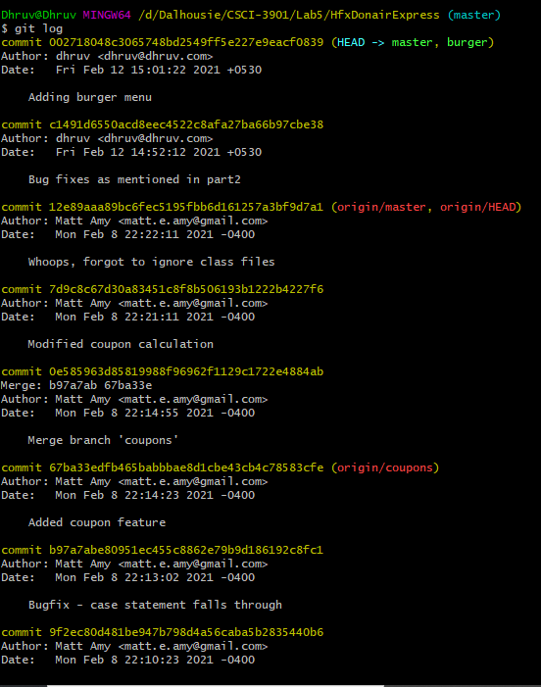

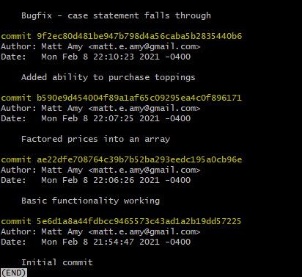

**Questions**

**When working alone on a project, how frequently should you commit you code to a version control system? Explain why.**

* When working alone on a project, one should practice committing to control system only when major change is applied to the code.
* Some of these changes includes – change of data structure, reorganizing code structure, change on logic, optimizing memory allocation, renaming important variables, adding new functionality.
* Someone is works alone is advised to commit such type changes when made to the system, as he/she is only responsible for the code to work.
* Suppose, when such changes are made to a particular functionality, it’s possible that some other method, which relies on outcome of this code, may face issues and will not work as expected to be.
* In that case, assume one has made several changes and with each change, has commit to the control system. And after making those changes, when one tests the modified code at once and error occurs, that individual can easily check after which modification does the code become faulty and rollback to that version.

**When working in a team, how frequently should you commit you code to a version control system? Explain why.**

* When it comes to working on a project in a team, one must commit only after ensuring proper working of the added change and also he/she must ensure the existing functionalities does not break down due to the change made.
* Therefore, commit should be done functionality by functionality. So that other team members can better understand the added functionality as it would be hard to understand everything at once.

**Why might you create branches for your project in your version control system?**

* Branches are created so that we can test and verify the existing and the added changes effectively without worrying about main branch.
* After BVT (Build Verification Testing) of the new branch we can merge it to main branch ensuring reliability.